BANK RECONCILIATION WHITLEY PC
31st MARCH 2025

CASH BOOK | £
Balance b/f | 17854
Receipts | 14753
Payments | 14737
Balance c/f | 17870
BANK BALANCE
Current A/C | 100
Deposit A/C | 17770
LESS
Unpresented cheque
 | 17870

Tracey Noble
Clerk to Whitley Parish Council

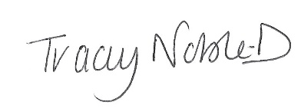

Dated 07 April 2025

