BANK RECONCILIATION WHITLEY PC
31st MARCH 2024

CASH BOOK | £
Balance b/f | 13960
Receipts | 17099
Payments | 13205
Balance c/f | 17854
BANK BALANCE
Current A/C | 100
Deposit A/C | 17754
LESS
Unpresented cheque
 | 17854

Tracey Noble
Clerk to Whitley Parish Council

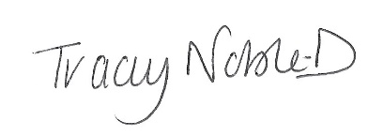

Dated 02 April 2024

