Dear Councillor

You are summoned to attend a meeting of the Parish Council which will be held on Tuesday 18th February 2025 at 7.00pm in Whitley Village Hall, Village Lane, Higher Whitley.
Please advise me as soon as possible if you are unable to attend.

Signed:
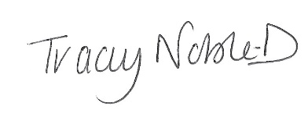
Clerk to the Parish Council
13th February 2025

Agenda
- Apologies
- Declaration of Interest
- Minutes of the Previous Meeting – 21st January 2025
- Public Forum - In accordance with the Standing Orders, the meeting shall be adjourned for a maximum of 30 minutes for Public Participation. Speeches will not last for more than 3 minutes
- To Receive the Report from Cheshire West and Chester Borough Councillors
- To Consider Received Planning Applications
- To Note Received Correspondence
- To Agree Finance – Payments Made Under Clerk’s Delegated Authority
- To Note Review of Policies
- Village Flood Working Group
- VE Day – 8th May 2025
- Whitley Nature Reserve
- Dark Lane Update
- Greenhills Update
- To Note Matters Arising
- Time and Date of Next Meeting

If any member of the public wishes to attend the meeting, please contact the clerk before the meeting.

