Dear Councillor

You are summoned to attend a meeting of the Parish Council which will be held on Tuesday 18 April 2023 at 7.30pm in Whitley Village Hall, Village Lane, Higher Whitley.
Please advise me as soon as possible if you are unable to attend.

Signed:
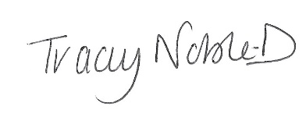
Clerk to the Parish Council
12 April 2023

Agenda
- Apologies
- Declaration of Interest
- Minutes of the Previous Meeting – 21 March 2023
- Public Forum - In accordance with the Standing Orders, the meeting shall be adjourned for a maximum of 30 minutes for Public Participation. Speeches will not last for more than 3 minutes
- To Receive the Report from Cheshire West and Chester Borough Councillors
- Planning
- Finance
- Correspondence
- Maintenance of Parish Roads
- Millennium Gardens
- Coronation Volunteer Committee Update
- To Note Matters Arising
- Time and Date of Next Meeting

If any member of the public wishes to attend the meeting, please contact the clerk before the meeting.

