Dear Councillor

You are summoned to attend a meeting of the Parish Council which will be held on Tuesday 27 September 2022 at 7.30pm in Whitley Village Hall, Village Lane, Higher Whitley.
Please advise me as soon as possible if you are unable to attend.

Signed:
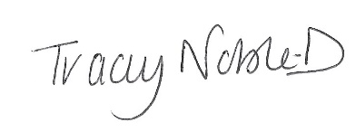
Clerk to the Parish Council
20 September 2022

Agenda
- Apologies
- Declaration of Interest
- Minutes of the Previous Meeting – 19 July 2022
- Public Forum - In accordance with the Standing Orders, the meeting shall be adjourned for a maximum of 30 minutes for Public Participation. Speeches will not last for more than 3 minutes
- To Receive the Report from Cheshire West and Chester Borough Councillors
- Planning
- Finance
- Correspondence
- External Auditor Appointment Arrangements
- Queen’s Orchard
- Adoption and Revise of Policies
- Parish Council Logo
- To Note Matters Arising
- Time and Date of Next Meeting

If any member of the public wishes to attend the meeting, please contact the clerk before the meeting as there is a restriction of number of people that can attend due to Covid.

