Dear Councillor

You are summoned to attend a meeting of the Parish Council which will be held on Tuesday 21 June 2022 at 7.30pm in Whitley Village Hall, Village Lane, Higher Whitley.
Please advise me as soon as possible if you are unable to attend.

Signed:
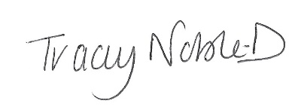
Clerk to the Parish Council
14 June 2022

Agenda
- Apologies
- Declaration of Interest
- Minutes of the Previous Meeting – 17 May 2022
- Public Forum - In accordance with the Standing Orders, the meeting shall be adjourned for a maximum of 30 minutes for Public Participation. Speeches will not last for more than 3 minutes
- Casual Vacancy Co-option
- To Receive the Report from Cheshire West and Chester Borough Councillors
- Planning
- Finance
- Correspondence
- Town Pit
- Village Maintenance Contract
- Queen’s Platinum Jubilee Report
- To Note Matters Arising
- Time and Date of Next Meeting

If any member of the public wishes to attend the meeting, please contact the clerk before the meeting as there is a restriction of number of people that can attend due to Covid.

