Dear Councillor
You are duly summoned to participate in the Extraordinary Meeting of the Parish Council, called by the Chairman, which will be held on Tuesday 24 May 2022 at 6.10pm in Whitley Village Hall, Village Lane, Higher Whitley.
Please advise me as soon as possible if you are unable to attend.
Signed:
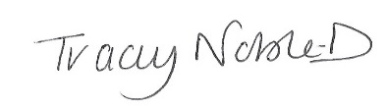
Clerk to the Parish Council
20 May 2022

Extraordinary Meeting Agenda
- Apologies
- Declaration of Interest
- Co-option of Casual Vacancy
- Close of Meeting

