Dear Councillor
You are summoned to attend the Annual Meeting of the Parish Council which will be held on Tuesday 17 May 2022 at 7.00pm in Whitley Village Hall, Village Lane, Higher Whitley.
The meeting of the Parish Council will commence at 7.30pm.
The Annual Parish Assembly will commence at 8.00pm.
Please advise me as soon as possible if you are unable to attend.
Signed:
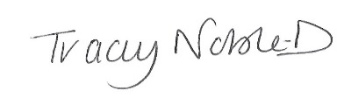
Clerk to the Parish Council
10 May 2022
Annual Meeting of the Parish Council Agenda
- Apologies
- Chairman’s Statement
- Election and Appointment of Chair
- Election and Appointment of Vice Chair
- Acceptance of Office Signed
- Election and Appointment of Village Hall Representative
- Election and Appointment of Burleymen
Parish Council Meeting Agenda
- Declaration of Interest
- Minutes of the Previous Meeting – 26 April 2022
- Public Forum - In accordance with the Standing Orders, the meeting shall be adjourned for a maximum of 30 minutes for Public Participation. Speeches will not last for more than 3 minutes.
- To Receive the Report from Cheshire West and Chester Borough Councillors
- Planning
- Finance
- Correspondence
- To Note Matters Arising
- Time and Date of Next Meeting
Annual Parish Assembly
Meet the Parishioners and Light Refreshments Available

